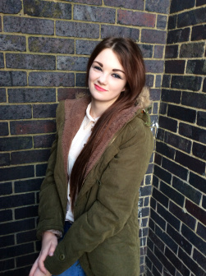
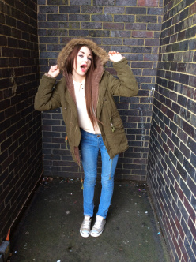
How does your media product represent particular social groups?
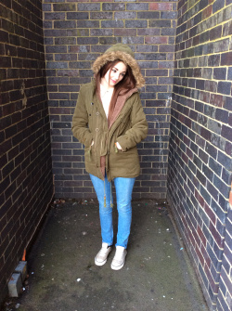
My product is aimed at a teenage audience, therefore, it represents a similar social group, to our magazine which we called ‘Fresh’, as the content, style and text are all very straight forward and similar. My model on my front cover is posed so she is looking straight at the camera and that engages the audience, it makes them feel like they have a connection with the model on the cover. I made my model central of the page because I wanted it to be all about her.
I put all my subheadings around her so it didn’t look messy or boring. I made my model the only image on my front cover because I didn’t want anything else in the way of her making it look over crowded and messy I did this because I wanted all the focus on my model. I edited my images as I removed the background of my original image and I inserted a random wall from Google images because I thought it went better with the image and I wanted it to look more like a magazine would, more professional.
I made my images match my color scheme for the magazine because I wanted it to look choreographed and I wanted a good feel about my magazine cover. With my double page spread, since the content is about music and love life I made the images look really serious. I tried to take shots of my model in different areas such as black bricked wall, yellow striped fence and a class room and I used all different angles of her.
I got my model to pose in all different positions whilst I took high and low angled shots, medium close ups and extreme close ups of her. I ended up using medium close up shots of my model for my final piece because I thought this was more intimate but not as intimate as an extreme close up shot would be of her. I thought a medium close up would look nice for the magazine and I really liked the photo’s I had taken of my model. I got my model to dress casually and very stereotypical teenager because that would make the audience feel more comfortable and make the audience feel like they could relate to what my model was dressed in and I really liked the idea of it being a casual looking magazine it fits with the R&B vibe. Whilst I was researching what kind of thing to put on my cover a lot of the R&B artists were casual and they looked extremely normal and that’s what I wanted to go for because I really liked the idea of it. My research also gave me inspiration for style, vibe and color schemes.

