Who would be the target audience for your media product?

My target audience for my R&B magazine would be 13-20 I’d say, a good range but mainly teenagers. I think this age group is suitable for our magazine because our content is easy to read, its eye catchy and it’s very affordable for a teenager. We had to consider that teenagers under 16 may not be working and won’t have their own money so we had to make the budget affordable for them. The target for my music magazine is aimed at teenage girls, as the conventions and colors are going to attack a female more than a male. The target audience is based around R&B fans as the information the magazine gives out wouldn’t be interesting for someone who likes pop music for example. I mention some huge R&B artists on my front page such as ‘Rihanna’ and ‘Drake’.

R&B audience profiling.

Name: Chloe Mckay
Age: 16
Favorite Artist: Beyoncé
Hobbies: Reading

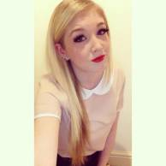

Name: Nadine Kent
Age: 17
Favorite Artist: Alicia Keys
Hobbies: Social Networking

