What have you learnt about technologies from the process of constructing this product?
Equipment:
- iPad Air
- Computer
- USB
Programs I used:
- Microsoft PowerPoint
- fontspace.com
- google.com
I used my iPad Air to take my photographs of Adele (my model) and using my USB cable I uploaded them onto the school computers. I then put them onto Microsoft PowerPoint slides and I had a look at which photographs I preferred more than the others. I made a select few and I started editing the background out of them to experiment with new ones. I used Microsoft PowerPoint to do all my editing and making of my magazine.
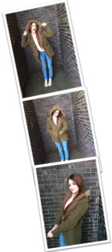
I used font space so I could experiment with different font styles for my magazine, once I found the font I liked and wanted to use I copy and paste the words into a PowerPoint presentation and placed it onto my work. I used Google to look up black wall background for my original images to be placed on.
Slide share has allowed me to share my work, and upload them to my blog, to make it easier for them to see my planning and final piece.

